**MI.M.5.1.0.0** Operations and algebraic thinking

**MI.M.5.1.1.0** Writing and interpret numerical expressions

**MI.M.5.1.1.1** use parentheses, brackets or braces in numerical expressions and evaluate with these symbols

Ex: 2x(5+3)-(7+2), 32/(2x4)

**MI.M.5.1.1.2** Write simple expressions that record calculations with numbers, and interpret numerical expressions without evaluating them

Ex: Double 5 then add 2 == 5x2+2 or (5x2)+2

**MI.M.5.1.2.0** Analyze patterns and relationships

**MI.M.5.1.2.1** Generate two numerical patterns using two given rules. Identify apparent relationships between corresponding terms. Form ordered pairs consisting of corresponding terms from the two patterns and graph the ordered pairs on a coordinate plane.

Ex: 1 cup of flour makes 2 cupcakes how many cupcakes with 5 cups of flour?1=2, 2=4, 3=6, 4=8, 5=10 put in table and plot graph

**MI.M.5.2.0.0** Number and Operations in base 10

**MI.M.5.2.1.0** Understanding the place value system

**MI.M.5.2.1.1** Recognize that in multi-digit number, a digit in one place represents 10 times as much as it represents in the place to its right and 1/10 of what it represents in the place to its left

Ex: 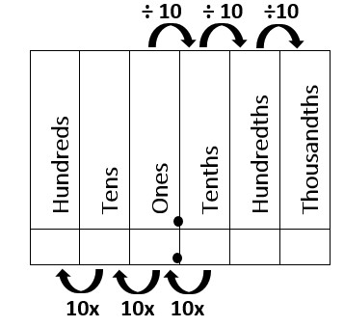

**MI.M.5.2.1.2** Explain patterns in the number of zeros of the product when multiplying a number by powers of 10 and explain patterns in the placement of the decimal point when a decimal is multiplied or divided by a power of 10. Use whole-number exponents to denote powers of 10

Ex: $8/{10}^{1} = .8$ or $8x{10}^{1} = 80$

$8/{10}^{2} = .08$ or $8x{10}^{2} = 800$

**MI.M.5.2.1.3** use place value understanding to round decimals to any place

Ex: 9.8765 round to the 10ths place(.1) = 9.9 or 345.4543 round to the 100ths place(.01) = 345.45

**MI.M.5.2.2.0** Perform operations with multi-digit whole numbers and with decimals to hundredths

**MI.M.5.2.2.1** fluently multiply multi-digit whole numbers using the standard algorithm

Ex: 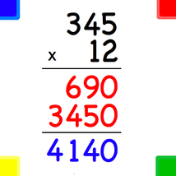

**MI.M.5.2.2.2** Find whole-number quotients of whole numbers with up to four-digit dividends and two-digit divisors, using strategies based on place value, the properties of operations, and/or the relationship between multiplication and division. Illustrate and explain the calculation by using equations, rectangular arrays, and/or area models.

Ex: 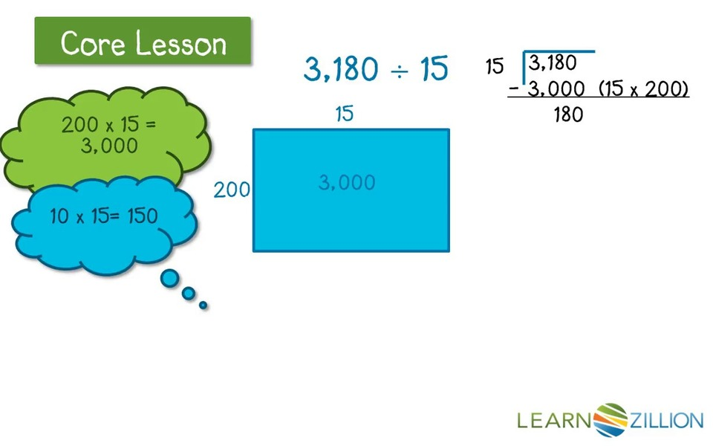

**MI.M.5.2.2.3** Add, subtract, multiply, and divide decimals to hundredths, using concrete models or drawings and strategies based on place value, properties of operations, and/or the relationship between addition and subtraction; relate the strategy to a written method and explain the reasoning used.

Ex: .3 x .4 = ? well 3/10 x 4/10 = 12/100 so .3 x .4 = .12

.4 + .7 = 1.1 not .11 because 4/10 + 7/10 = 11/10 or 1 and 1/10

**MI.M.5.3.0.0** Number and Operations – Fractions

**MI.M.5.3.1.0** Use equivalent fractions as a strategy to add and subtract fractions

**MI.M.5.3.1.1** Add and subtract fractions with unlike denominators (including mixed numbers) by replacing given fractions with equivalent fractions in such a way as to produce an equivalent sum or difference of fractions with like denominators.

Ex: $\frac{2}{3} + \frac{5}{4} = \frac{8}{12} + \frac{15}{12} = \frac{23}{12}$

**MI.M.5.3.1.2** Solve word problems involving addition and subtraction of fractions referring to the same whole, including cases of unlike denominators, e.g., by using visual fraction models or equations to represent the problem. Use benchmark fractions and number sense of fractions to estimate mentally and assess the reasonableness of answers.

Ex: I bought 5/6 gallon of paint but only used ½ of a gallon how much do I have left so…. $\frac{5}{6} - \frac{1}{2} = \frac{5}{6} - \frac{3}{6} = \frac{2}{6} or \frac{1}{3}$

**MI.M.5.3.2.0** Apply and extend previous understanding of multiplication and division to multiply and divide fractions

**MI.M.5.3.2.1** Interpret a fraction as division of the numerator by the denominator (a/b = a ÷ b). Solve word problems involving division of whole numbers leading to answers in the form of fractions or mixed numbers, e.g., by using visual fraction models or equations to represent the problem.

Ex: he ate ¼ of a pizza if the pizza had 12 pieces how many did he eat so… ¼ x 12 = 12/4 or 3 pieces

**MI.M.5.3.2.2** Apply and extend previous understandings of multiplication to multiply a fraction or whole number by a fraction.

Ex: 4 x ½ or (1/2 +1/2 +1/2 + ½) = 4/2 or 2

**MI.M.5.3.2.3** Interpret multiplication as scaling(resizing)

Ex:

**MI.M.5.3.2.4** Solve real world problems involving multiplication of fractions and mixed numbers ,e.g., by using visual fraction models or equations to represent the problem.

Ex: 4 x 2 ¾ show as 4 groups of 2 ¾ pies to be able to see how many pies there are = 11

**MI.M.5.3.2.5** Apply and extend previous understandings of division to divide unit fractions by whole numbers and whole numbers by unit fractions.

Ex: 1/3 / 4 = 1/12 or ¼ / 2 = 1/8

**MI.M.5.4.0.0** Measurement and Data

**MI.M.5.4.1.0** Convert like measurement units within a given measurement system

**MI.M.5.4.1.1** Convert among different-sized standard measurement units within a given measurement system (e.g.,convert5 cmto0.05 m), and use these conversions in solving multi-step, real world problems.

Ex: 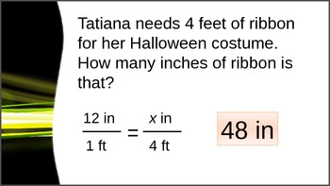

**MI.M.5.4.2.0** Represent and Interpret data

**MI.M.5.4.2.1** Make a line plot to display a data set of measurements in fractions of a unit(1/2,1/4,1/8).Use operations on fractions for this grade to solve problems involving information presented in line plots.

Ex:

**MI.M.5.4.3.0** Geometric Measurement: understand concepts of volume and relate volume to multiplication and to addition

**MI.M.5.4.3.1** Recognize volume as an attribute of solid figures and understand concepts of volume measurement.

Ex:

**MI.M.5.4.3.2** Measure volumes by counting unit cubes, using cubic cm, cubic in, cubic ft, and improvised units

Ex:

**MI.M.5.4.3.3** Relate volume to the operations of multiplication and addition and solve real world and mathematical problems involving volume.

Ex:

**MI.M.5.5.0.0** Geometry

**MI.M.5.5.1.0** Graphing points on the coordinate plane to solve real-world and mathematical problems

**MI.M.5.5.1.1** Use a pair of perpendicular number lines, called axes, to define a coordinate system, with the intersection of the lines (the origin) arranged to coincide withthe0 on each line and a given point in the plane located by using an ordered pair of numbers, called its coordinates. Understand that the first number indicates how far to travel from the origin in the direction of one axis, and the second number indicates how far to travel in the direction of the second axis, with the convention that the names of the two axes and the coordinates correspond

Ex:

**MI.M.5.5.1.1** Represent real world and mathematical problems by graphing points in the first quadrant of the coordinate plane and interpret coordinate values of points in the context of the situation.

Ex:

**MI.M.5.5.2.0** Classify 2 Dimensional figures into categories based on their properties

**MI.M.5.5.2.1** Understand that attributes belonging to a category of two-dimensional figures also belong to all subcategories of that category.

Ex:

**MI.M.5.5.2.2** Classify two-dimensional figures in a hierarchy based on properties.

Ex: